## Question 1

1. What are models. Provide some examples of models.

* Meaning – a representation (description)
* Meaning - a model is a [pattern](http://en.wikipedia.org/wiki/Pattern), plan, representation, or description of some important aspect of the real world
* Purpose – designed to show the structure or workings of an object, system, or concept.

1. Why is data model important?

* A data model is drawn at logical level and is a conceptual model.
* A data model acts as a communication tool facilitating the interaction between designers, application programmers and the end-user.
* Data models organize data for various users with different needs eg. inventory database.
* **A Better Final Product –** All else being equal, a finished information system based on a sound conceptual model should provide more functionality and less errors than a system lacking an effective model.
* **Increased Specificity for Experts –** An elegant model will classify components in an intuitive way allowing design problems to be decomposed and assigned to relevant experts.
* **Improved Communication Between Developers –** An effective model synchronizes common vocabulary and allows experienced developers to work at a higher level of abstraction (assuming all developers are able to “stay on the same page”).
* **Improved Communication with Others –** An effective model will also support communication between all participants: (1) analysts, (2) users, (3) experienced developers, and (4) novice developers (or developers new to a particular system).
* **Increased Domain Understanding –** The process of creating a conceptual model forces analysts to better understand the domain for a particular information system. Additionally, analysts, developers, and users who are new to a system can use the existing model to aid their understanding.
* **Guide Design Decisions –** While a conceptual model should be created independent of any “downstream” considerations, an effective model may assist developers in selecting various design alternatives to build on the underlying data model.
* **Stronger Documentation –** A strong conceptual model should encourage stronger documentation of business requirements, which could prove useful for future reference.

1. Provide a logical view of data which stores supplier details. In the logical view, provide some examples of the data stored. Label key field, non-key fields (attributes) and records clearly on the logical view of data you have provided.

non-key fields

**Supplier Table**

Records

key fields

|  |  |  |  |  |
| --- | --- | --- | --- | --- |
| Supplier no.  (PK) | Supplier Name | Address | Telephone | Email |
|  |  |  |  |  |
|  |  |  |  |  |

## *Question 2*

1. Define what ‘business rules’ are. Give TWO (2) examples of business rules used in a payment system (for accounts receivable).

A business rule is defined as any brief, precise, and unambiguous description of policy, procedure, or principle within a specific organization (Coronel, Rob, 31, 2007). Business rules are maintained in writing and reflect the appropriate actions in the day-to-day operations of an organization.  
  
Business rules are generally developed by the managers and policy makers within an organization. Sometimes, these rules are even derived from the input of end users; however, this can be slightly less reliable due to differing perceptions.  
  
Identifying business rules can be a critical part of database design for several reasons. Incorporating business rules into design promotes a better understanding of the purpose of the managed data. Designers learn to develop designs to fit both the company's scope as well as the data itself. This leads to the most accurate possible database model.

2 examples of business rules in a payment system:

* A customer may make many payments on account. Each payment on account is credited to only one customer. (One to many relationships)
* A customer may receive many invoices. Each invoice is received by only one customer. (One to many relationships)

1. Explain FOUR (4) main purposes of business rules. (Any 4 below)

* Used to define a conceptual model of the business of an organisation and how they are applied to information systems.
* Used for the organization that stores or uses data to be an explanation of a policy, procedure, or principle.
* Business rules allow the creator to develop relationship participation rules and constraints and to create a correct data model.
* They also allow the creators to understand business processes, and the nature, role and scope of the data.
* They are a communication tool between users and creators, and they also help standardize the company’s view of the data.
* Help employees focus on and implement the actions within the organizations environment.

## Question 3

1. Create a Crow’s Foot ERD to include the following business rules for the ProdCo company :

* Each sales representative writes many invoices
* Each invoice is written by one sales representative
* Each sales representative is assigned to one department
* Each department has many sales representatives
* Each customer can receive many invoices
* Each invoice is received by one customer.

Suggested Answer:

SALES REP

INVOICE

DEPT

CUSTOMER

(b) List any SIX (6) characteristics of a relation in a relational database model.

Suggested Answer: (Any 6 below)

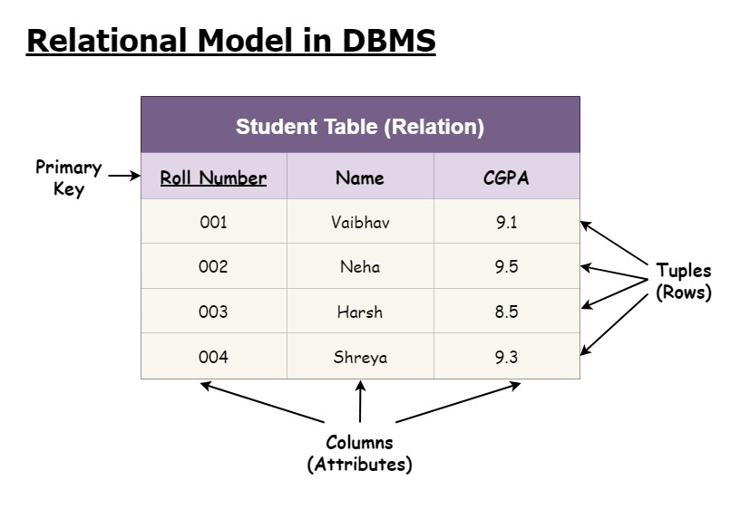

* Two-dimensional structure - rows and columns.
* Rows (tuples/records) represent single entity.
* Columns represent attributes/fields.
* Row/column intersection represents single value.
* Tables must have an attribute or a combination of attributes to uniquely identify each row. (Primary Key / Composite Key)
* Column values all have same data format. (Text / Number …)
* Each column has range of values called attribute domain. (CGPA -> 0.000 – 4.000, Age -> 21 – 99, Year_Of_Study -> Jr. Sr. So.Fn.)
* Order of the rows and columns is immaterial (not important) to the DBMS.

## Question 4

Using figure below from Microsoft Access as your guide, answer the following questions. The Tiny College relational diagram shows the initial entities and attributes for Tiny College.

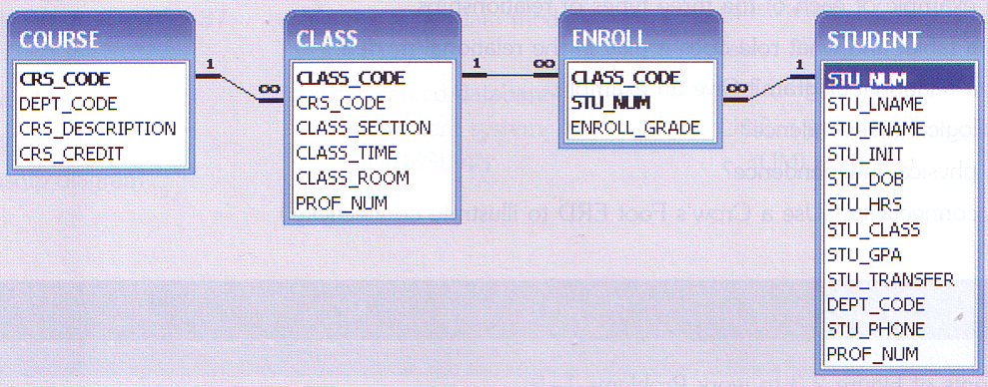

1. Identify each relationship type and write all the business rules. Explain the rules if necessary.

Suggested Answer:

|  |  |  |  |
| --- | --- | --- | --- |
| ENTITY | Relationship Type | ENTITY | Business Rules |
| COURSE | 1:M | CLASS | A course can generate many classes.  Each class is a section of only one course. |
| CLASS | 1:M | ENROLL | A class can enroll many students.  (This means that a class can appear many times in the ENROLL table—that's because a class can have many students.) |
| STUDENT | 1:M | ENROLL | A student can enroll in many classes.  (This means that a student can appear many times in the ENROLL table—that's because a student can take more than one class.) |

1. Create the basic Crow’s Foot ERD for Tiny College.

Suggested Answer:

COURSE

CLASS

ENROLL

STUDENTS

1. Create the network model that reflects the entities and relationships you identified in the relational diagram.

Suggested Answer:

Course

Class

Class

Class

Student

Student

## Question 5

The following is a brief summary of business rules for the ROBCOR cinema:

A cinema can play many movies. Each movie can be played at many cinemas. The date and time of a movie played at a particular cinema must be recorded. The attributes for movie are Movie ID, Title, Actors, and Category. The attributes for cinema are Cinema Code, and Cinema Name. Each ticket is referred to only one movie, and each movie can issue many tickets. The attributes for ticket are Ticket No, Price, and Seat No. Each ticket may or may not be reserved by an audience, but each audience can reserve many tickets. The attributes for audience are IC, Name, and Contact No.

1. Draw an initial ERD
2. Draw a revised ERD to resolve any many to many relationship
3. Provide a list of attributes for each entity. In your listing, indicate the primary keys (PK), any foreign keys (FK1, FK2)

Suggested Answer:

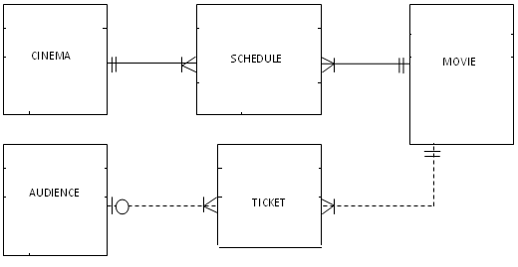

**Movie Entity:**

Attributes:

Movie ID (PK)

Title

Actors

Category

**Schedule**:

Movie ID (FK1)

Cinema Code (FK2)

Date

Time

**Cinema Entity:**

Attributes:

Cinema Code (PK)

Cinema Name

**Ticket Entity:**

Attributes:

Ticket No (PK)

Price

Seat No

Movie ID (FK1)

Audience IC (FK2)

**Audience Entity:**

Attributes:

IC (PK)

Name

Contact No

\***A dashed line** in an ERD denotes a foreign key*

## Question 6

Consider the following business rules for a newly developed housing property in a well-known local tourism industry:

A buyer can purchase many condominium units. A unit can be owned by many shared owners. The attributes of buyer are B_Name, B_NRIC, B_Address, B_Phone and B_Email. The Date_of_Purchase of a particular unit must be recorded. The attributes of unit are Unit_No, Floor_Level, Sqr_Feet and No_of_Room.

A condominium unit has many rooms. Each room is attached in a unit with a unique Room_No and Room_Type. A room may have zero or many tenants, but each tenant can rent only one room. The attributes for tenant are T_NRIC, T_Name and T_Phone.

Using a Crow’s Foot notation, draw an Entity Relationship Diagram (ERD) for the above scenario. Resolve many-to-many relationship, if any.

Suggested Answer:

Buyer

Own

Unit

Room

Tenant

Entities:

**Buyer:**

B_Name

B_NRIC

B_Address

B_Phone

B_Email

**Unit:**

Unit_No (Primary key)

Floor_Level

Sqr_Feet

No_of_Room

Date_of_Purchase

**Own**:

Unit_No

B_NRIC

**Room:**

Room_No (Primary key)

Room_Type

Unit_No (Foreign key referencing Unit)

**Tenant:**

T_NRIC (Primary key)

T_Name

T_Phone

Room_No (Foreign key referencing Room)